

AQS AirVision Java Plug-In Starter Kit

Installation and Administration Guide

EN-Node

Version: 1.0

January 17, 2012

Logo

1368 How Lane

North Brunswick, New Jersey 08902

[www.enfotech.com](http://www.enfotech.com)

Restriction on Use and Disclosure of Document Information

This document includes data that should not be disclosed outside the business entity for which it was intended, indicated as the recipient on this title page. The entire document is copyrighted by enfoTech and is protected under the US copyright law and international treaties. No part of this document may be reproduced or transmitted in any form or by any means, electronic or mechanical, for any purpose, without express written permission from enfoTech & Consulting Inc.

Copyright © 2001 – 2010 by enfoTech & Consulting Inc. All Rights Reserved.

Revision History

|  |  |  |  |  |
| --- | --- | --- | --- | --- |
| Version | Date | Created By | Reviewed By | Description |
| 1.0 | 01/17/2012 | Peter Huang | Charlie Tsai |  |
|  |  |  |  |  |
|  |  |  |  |  |
|  |  |  |  |  |

Tables of Contents

1. Document Purpose 4

2. Plug-In Overview 4

3. Prerequisites 5

4. Installation Package 5

5. Installation Instruction 5

*5.1* Deployment of EPAAQS.JAR File 5

*5.2* Incorporating XML Header Template 5

*5.3* Create an AQS AirVision Domain in the Node Administration Console 6

*5.4* Modify DataWizardConfigAQS_AirVision_(Solicit/Query/Task)_v2EPA.xml 7

*5.5* Create an operation with the AQS AirVision Plug-In 7

5.5.1 AQS_AirVision_Query_v2 Query 7

5.5.2 AQS_AirVision_Solicit_v2 Solicit 10

5.5.3 AQS_AirVision_v2 Task 12

6. Test AQS AirVision Plug-In 16

*6.1* Task Scheduling 16

*6.2* Node Client Authentication Process 17

*6.3* Air Vision Query 18

*6.4* Air Vision Solicit 18

*6.5* XML Schema Validation 19

7. Plug-In Input Parameter Definition 21

# Document Purpose

The purpose of this document is to provide guidance on the setup, use, and maintenance of the EN-Node AQS AirVision Plug-In.

# Plug-In Overview

The following diagram outlines the AQS AirVision plug-in and its interaction with an existing AirVision data management system. The Plug-In includes three services: a query request, a solicit request, and a scheduled task. Because the scheduled task is still being drafted, this service is optional.

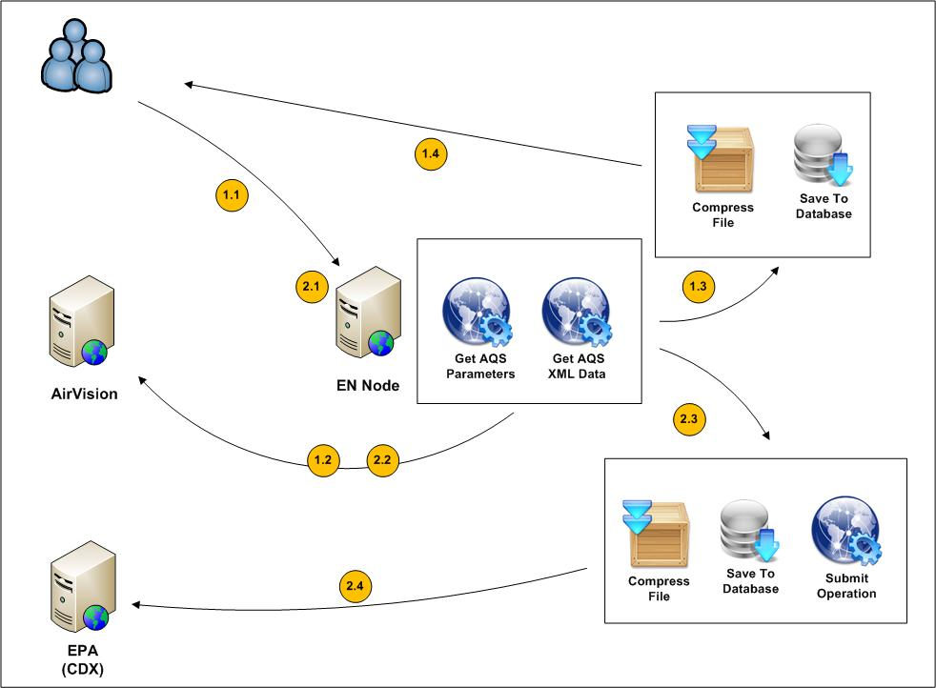

***Figure 1: AQS AirVision Plug-In Overview***

In the following sections, the AQS AirVision Plug-in is described in detail.

**Query and Solicit Requests**

|  |  |
| --- | --- |
| 1.1 | The user will execute a solicit or query request to the EN Node. |
| 1.2 | The AQS AirVision Plug-In will call on AirVision Services to retrieve data. |
| 1.3 | The retrieved data are compressed and stored in a XML format that meets the requirements of the EPA. |
| 1.4 | A solicit or query request will return the XML files to the user. Note that the query request skips the “compress file and save to database” step because the XML is returned to the user immediately. |

**Scheduled Task**

|  |  |
| --- | --- |
| 2.1 | A scheduled task will run submission requests to the EN Node. |
| 2.2 | The AQS AirVision Plug-In will call on AirVision Services to retrieve data. |
| 2.3 | The retrieved data are compressed and stored in a XML format that meets the requirements of the EPA and is ready for a submit operation to the EPA Central Data Exchange |
| 2.4 | A submit request will send the XML files to the EPA Central Data Exchange. |



# Prerequisites

* EN-Node application is installed
* An AQS AirVision web services available.

# Installation Package

* ORA_DML_20120112_AQS_ENNODE_patch.sql
* EPAAQS.jar
* DataWizardConfigAQS_AirVision_Query_v2EPA.xml
* DataWizardConfigAQS_AirVision_Solicit_v2EPA.xml
* DataWizardConfigAQS_AirVision_Task_v2EPA.xml

# Installation Instruction

## Deployment of EPAAQS.JAR File

Deploy the EPAAQS.jar file to the application server and make sure that the file is in the lib directory.

Node.Administration/ WEB-INF/lib

Node.Task/ WEB-INF/lib

Node.Client/ WEB-INF/lib

Node.WebServices/ WEB-INF/lib



## Incorporating XML Header Template

Before any AQS AirVision plug-in installation, the user should make sure that the AQS AirVision header template is incorporated into the XML file in accordance to the EPA. User must run the ORA_DML_20120112_AQS_ENNODE_patch.sql to create a template file in the database. A screenshot of the script is provided below:

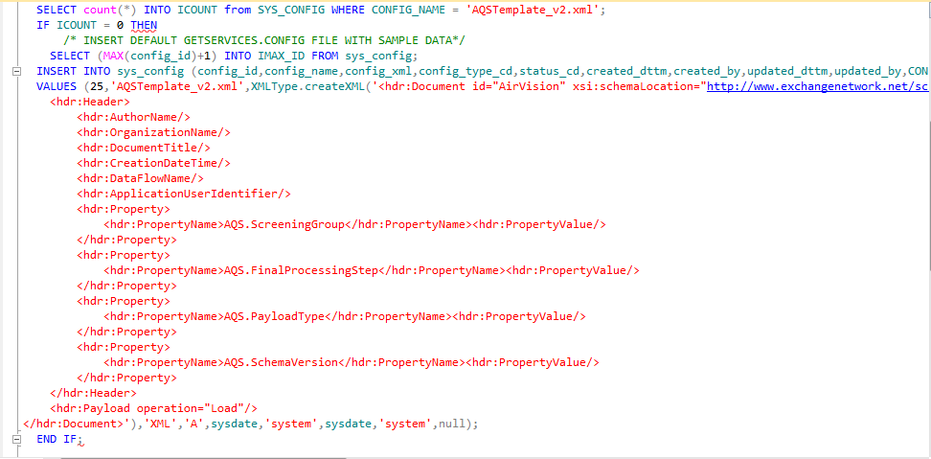

## Create an AQS AirVision Domain in the Node Administration Console

In order to create these operations using the AQS AirVision plug-in under the EN-Node, the user must first create a Domain. The Domain is a logical grouping of operations and is described below.

1. Log into the Node.Administration console with the appropriate username and password.
2. Click the “New Domain” link under the “Node Domain” Module and fill in the following information:
   * **Domain Name:** AQS
   * **Domain Administrator:** admin (or any other accounts you would like to manage the AQS AirVision file creation process)

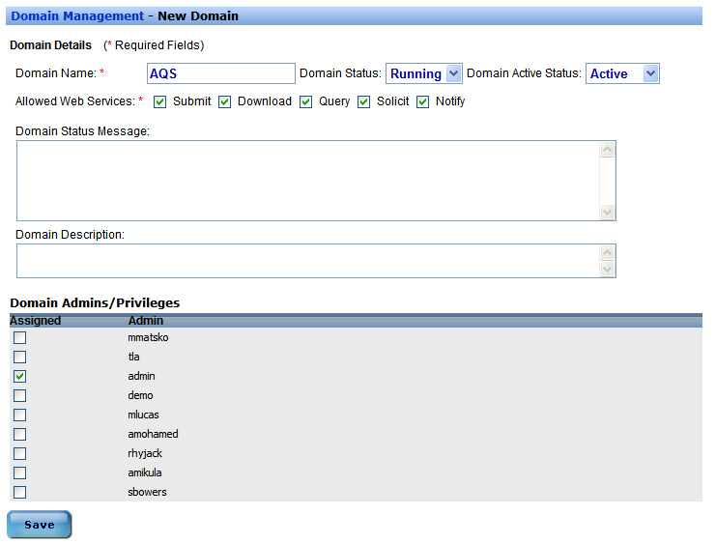

## Modify DataWizardConfigAQS_AirVision_(Solicit/Query/Task)_v2EPA.xml

Before uploading the XML file, the user must make a few modifications within the script. These changes are as follows:

* The operation domain name must match the name created in section 5.2
* The correct ID must be inputted
* The operation name must match the operation names that will be created in section 5.4. These are: AQS_AirVision_Query_v2, AQS_AirVision_Solicit_v2, and AQS_AirVision_Task_v2
* The operation type must be correct and match the operation types that will be created in section 5.4. This is either WEB_SERVICE or SCHEDULED TASK.
* The operation web service must match the ones that will be created in section 5.4. These are QUERY, SOLICIT, or TASK.

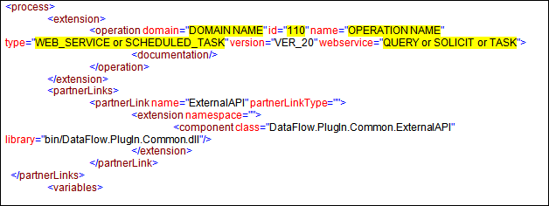

## Create an operation with the AQS AirVision Plug-In

There are a total of three operations to be created with this AQS AirVision package: AQS_AirVision_Query_v2, AQS_AirVision_Solicit_v2, and AQS_AirVision_Task_v2. The sections below describe how to configure each operation.

## AQS_AirVision_Query_v2 Query

1. Locate the “Node Domains” module from the Node Dashboard.
2. Under the “Node Domains” module, click the “Go to Operations” link for the AQS Domain

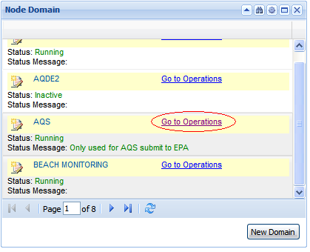

1. Click the “Create Operation” button
2. In the proceeding page, input the following parameters:

* Enter “AQS_AirVision_Query_v2” for Operation Name
* Select “Running” for Operation Status
* Select “WEB_SERVICE” for Operation Type
* Select “Yes” for Using Data Flow Wizard
* Click “Next”

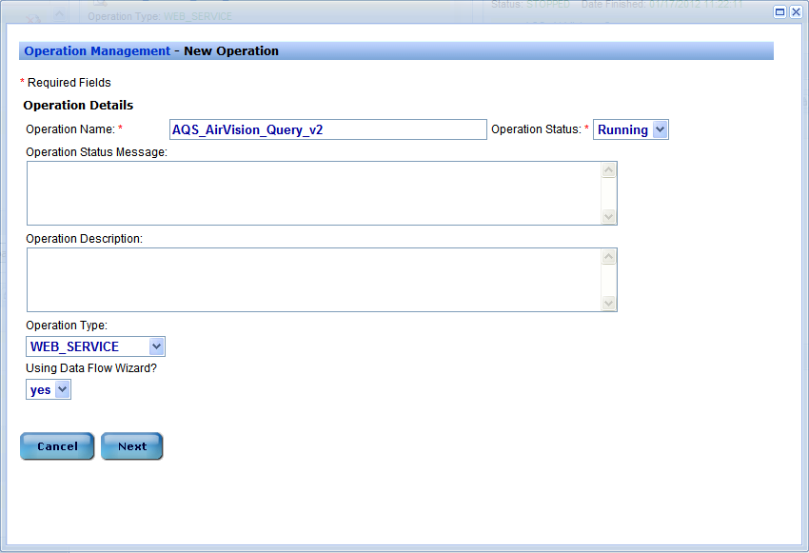

1. Click Save

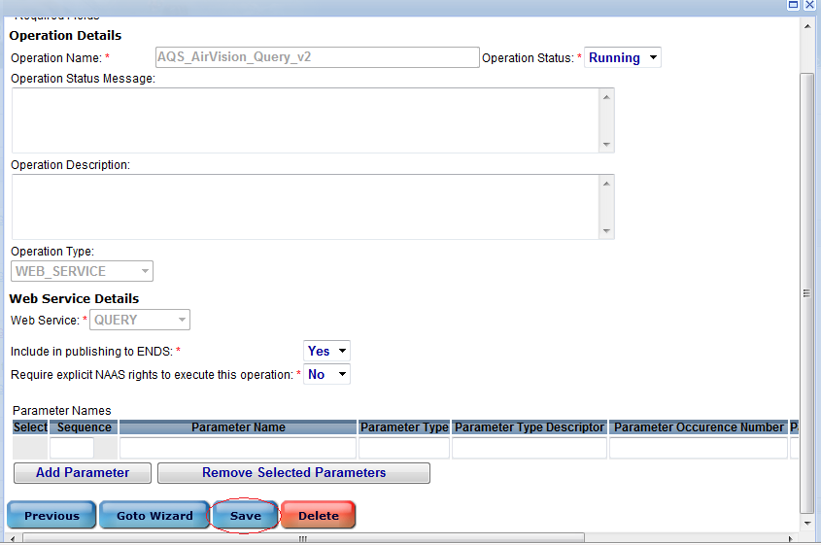

1. Return back to the Node Dashboard
2. Click “Data Wizard Configuration” under the “Node Configuration” Module

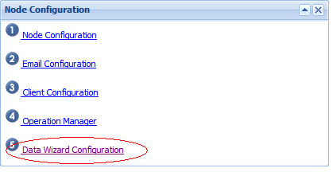

1. Within the page, select “AQS_AirVision_Query_v2” from the dropdown menu. Locate the DataWizardConfigAQS_AirVision_Query_v2EPA.xml file, and press “Upload”

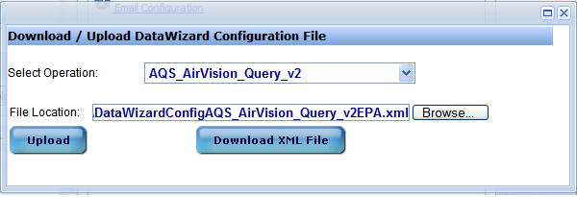

## AQS_AirVision_Solicit_v2 Solicit

1. Locate the “Node Domains” module from the Node Dashboard.
2. Under the “Node Domains” module, click the “Go to Operations” link for the AQS Domain



1. Click the “Create Operation” button
2. In the proceeding page, input the following parameters:

* Enter “AQS_AirVision_Solicit_v2” for Operation Name
* Select “Running” for Operation Status
* Select “WEB_SERVICE” for Operation Type
* Select “Yes” for Using Data Flow Wizard
* Click “Next”

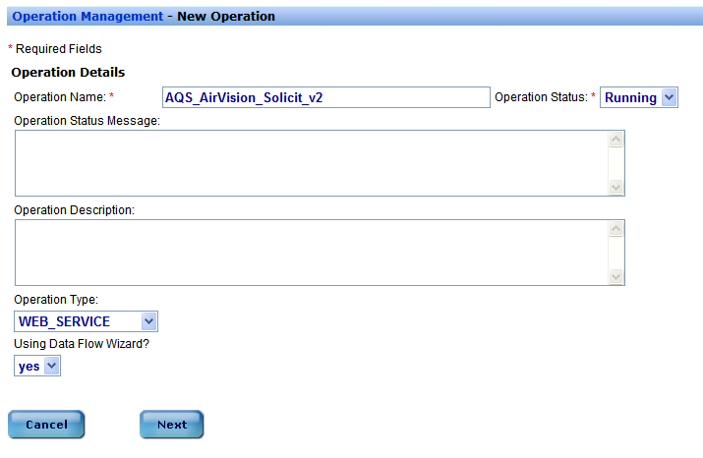

1. Click Save

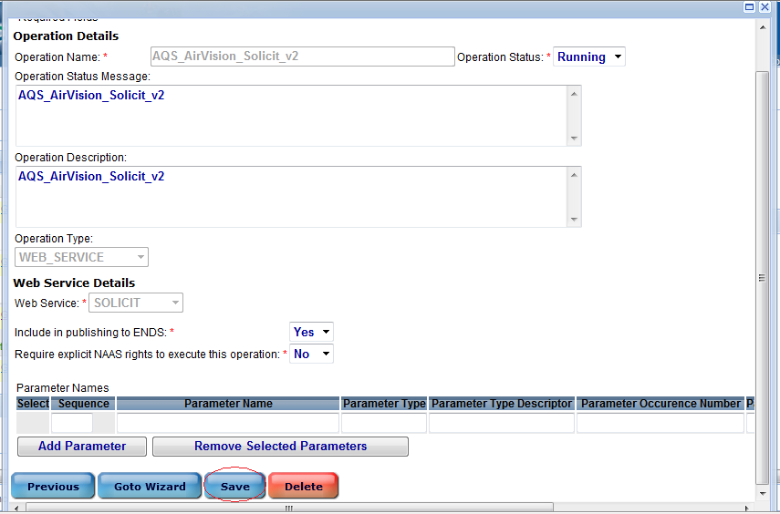

1. Return back to the Node Dashboard
2. Click “Data Wizard Configuration” under the “Node Configuration” Module



1. Within the page, select “AQS_AirVision_Solicit_v2” from the dropdown menu. Locate the DataWizardConfigAQS_AirVision_Solicit_v2EPA.xml file, and press “Upload”

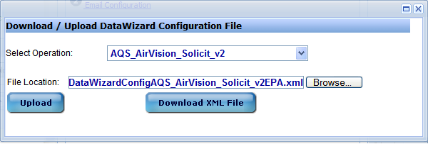

## AQS_AirVision_v2 Task

1. Locate the “Node Domains” module from the Node Dashboard.
2. Under the “Node Domains” module, click the “Go to Operations” link for the AQS Domain



1. Click the “Create Operation” button
2. In the proceeding page, input the following parameters:

* Enter “AQS_AirVision_v2” for Operation Name
* Select “Running” for Operation Status
* Select “SCHEDULED_TASK” for Operation Type
* Select “Yes” for Using Data Flow Wizard
* Click “Next”

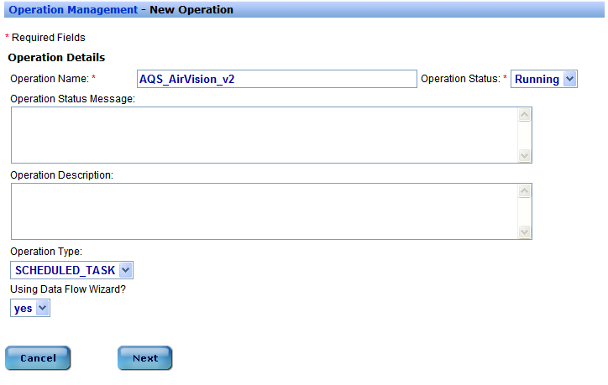

1. On the next page, input the following parameters:

* Select “Yes” for Include in publishing to ENDS
* Select “No” to Require explicit NAAS Rights to execute this operation
* Input the following with regards to the table shown below:

|  |  |  |
| --- | --- | --- |
| **Sequence** | **Parameter Name** | **Default Value** |
| 1 | EPAURL | https://testcdxnode64.epacdxnode.net/cdx-enws20/services/NetworkNode2ConditionalMtom |
| 2 | NAASUserID | Input NAAS User ID |
| 3 | NAASUserPassword | Input NAAS User Password |
| 4 | AirVisionURL | http://173.10.212.9:9889/AirVision.Services.WebServices.AQSXml/AQSXmlService/ |
| 5 | FileName | AQS_AirVision |
| 6 | AQSXMLSchemaVersion | 2.2 |
| 7 | CompressPayload | True |
| 8 | DurationCode | 1 |
| 9 | StartTime | 2011-10-01 |
| 10 | EndTime | 2011-11-30 |
| 11 | SendOnlyQAData | False |
| 12 | SendRATransactions | True |
| 13 | SendRBTransactions | True |
| 14 | SendRDTransactions | True |
| 15 | SendRPTransactions | True |
| 16 | AuthorName | Input Author Name |
| 17 | OrganizationName | Input Organization Name |
| 18 | DocumentTitle | Input Document Title |
| 19 | AQSUserID | Input AQS User ID |
| 20 | AQSScreeningGroup | Input AQS Screening Group |
| 21 | AQSPayloadTypeProperty | XML |
| 22 | AQSSchemaVersion | 2.0 |
| 23 | AQSLoadOptions | Load |
| 24 | PayloadOperation | Load |
| 25 | AgencyCode | AGENCY1|111 |
| 26 | SiteCode | 123 |
| 27 | ParameterCode | 42401 |

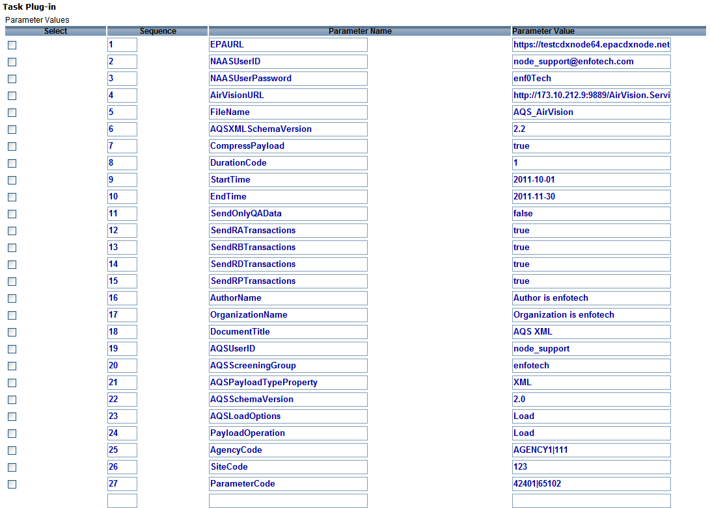

1. Click Save
2. Return back to the Node Dashboard
3. Click “Data Wizard Configuration” under the “Node Configuration” Module



1. Within the page, select “AQS_AirVision_Query_v2” from the dropdown menu. Locate the DataWizardConfigAQS_AirVision_Query_v2EPA.xml file, and press “Upload”

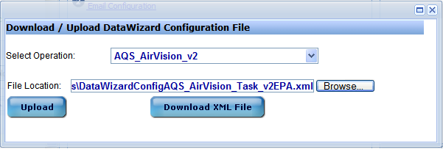

# Test AQS AirVision Plug-In

The user can test the three types of submissions for the AQS AirVision Plug-In. Section 6.1 will describe the process for a scheduled task (AQS_AirVision_v2). Section 6.2 will describe the authentication process required to access the node client, which will in turn allow users to conduct query and solicit actions. Section 6.3 will illustrate the process for a query task (AQS_AirVision_Query_v2). Section 6.4 will show the process for a solicit task (AQS_AirVision_Solicit_v2). Section 6.5 will show a general process to perform XML Schema Validation.

## Task Scheduling

1. Locate the “Node Domains” module from the Node Dashboard.
2. Under the “Node Domains” module, click the “Go to Operations” link for the AQS Domain



1. Click the “edit” link that corresponds to AQS_AirVision_v2

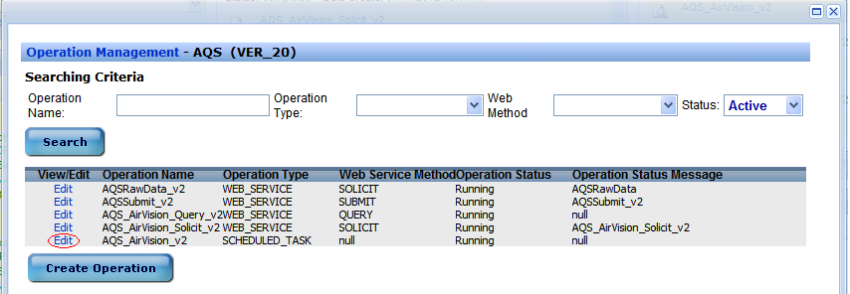

1. Within this page, change the scheduling type, which will allow the type to be inactive, once, seconds, days, weeks, months, and years. As an example, change the type to “once” and specify a start date and time. Click “Run Task”.

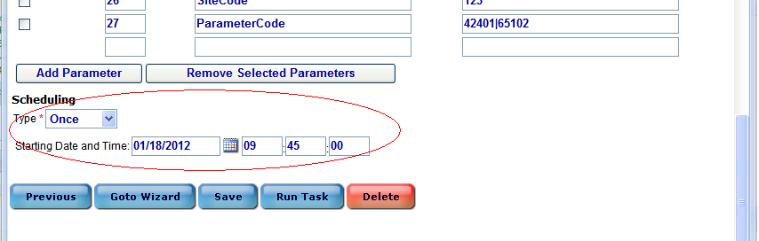

## Node Client Authentication Process

* + - 1. Go to the Node Client website at: <http://demo6.enfotech.net:8089/Node.Client/Page/Entry/FrameSet.jsp>
      2. Make sure the version of the node is set to “Node 2.0”
      3. Click “Authenticate” from the menu on the left panel.
* Pick the destination Node Address from the dropdown list (in our case, we want to pick demo6).
* Complete the authentication process by entering the NAAS user name and password.
* Click “Authenticate”.
* Once the authentication is complete, the account will be validated and a security token is returned on the bottom of the page.

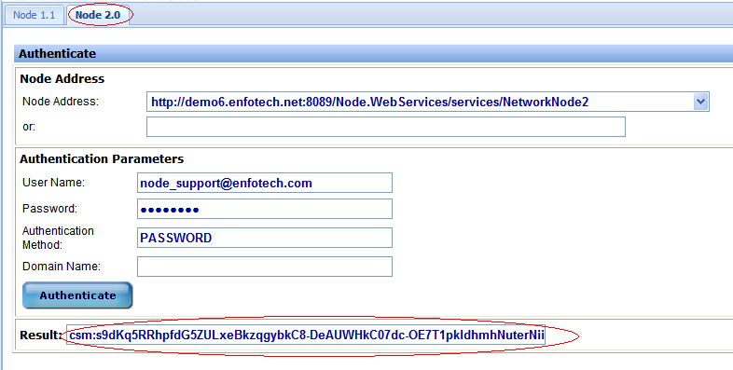

## Air Vision Query

1. Click “Query” from the menu on the left panel.

* The Node Address and Security Token should already be present upon entering this page.
* Select/Enter “AQS_AirVision_Query_v2” for both the Data Flow and the Request Name. A list of parameters should appear after selection.
* Input the values of the parameters. Use “Section 7: Stored Procedure Name” as a guide.
* Click “Query”. The result should show the XML file on the bottom of the page.

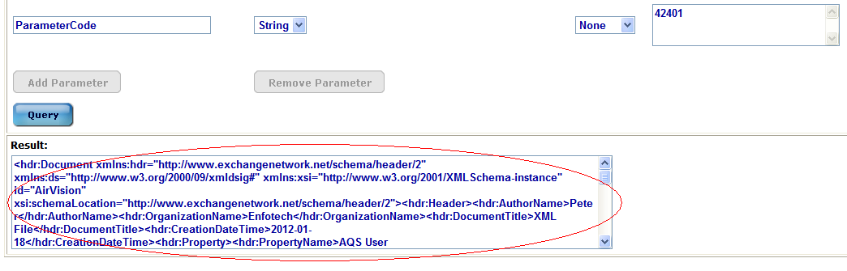

## Air Vision Solicit

1. Click “Solicit” from the menu on the left panel.

* The Node Address and Security Token should already be present upon entering this page.
* Select/Enter “AQS_AirVision_Solicit_v2” for both the Data Flow and the Request Name. A list of parameters should appear after selection.
* Input the values of the parameters. Use “Section 7: Stored Procedure Name” as a guide.
* Click “Solocit”. The result should show a transaction ID on the bottom of the page. Copy the Transaction ID for future use.

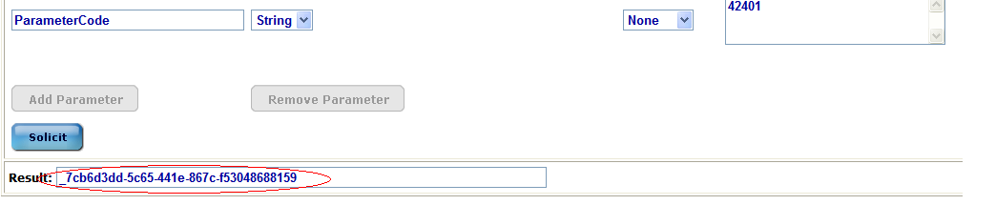

1. Click “GetStatus from the menu on the left panel”

* The Node Address and Security Token should already be present upon entering this page.
* Enter in the transaction ID that was just copied from the solicit request
* Click GetStatus. The status should show on the bottom of the page.

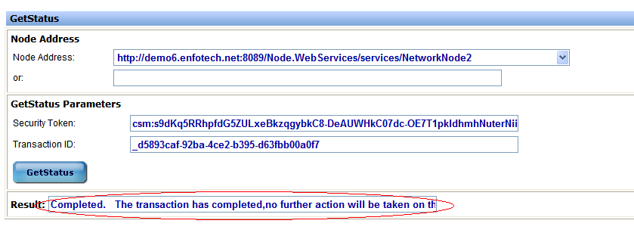

1. Click “Download” from the menu on the left panel.

* The Node Address and Security Token should already be present upon entering this page.
* Enter in the transaction ID that was just copied from the solicit request
* Enter “AQS_AirVision_Solicit_v2” for DataFlow
* Click Download. The file should show on the bottom of the page, ready to be downloaded

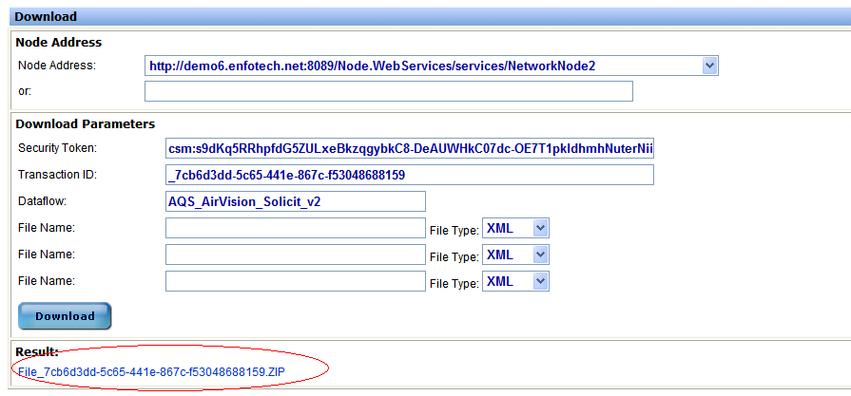

## XML Schema Validation

1. Open or Copy/Paste the retrieved XML file into an XML editing platform (such as XML Spy)
2. Validate the XML file within the platform

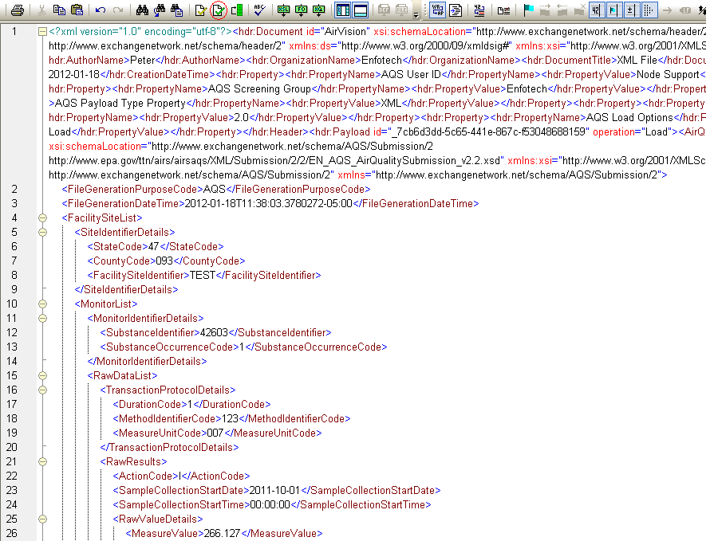

1. Conduct further validation by going to: <http://tools.epacdxnode.net/>

# Plug-In Input Parameter Definition

|  |  |  |  |
| --- | --- | --- | --- |
| **Parameter** | **Required?** | **Value** | **Example** |
| EPAURL | Yes | <https://testcdxnode64.epacdxnode.net/cdx-enws20/services/NetworkNode2ConditionalMtom> | Same as Value |
| NAASUserID | Yes | User Name | Enfotech |
| NAASUserPassword | Yes | Password | enfopassword |
| AirVisionURL | Yes | <http://173.10.212.9:9889/AirVision.Services.WebServices.AQSXml/AQSXmlService/> | Same as Value |
| FileName | No | File Name | testfile |
| AQSXMLSchemaVersion | No | Version Number | 2.2 |
| CompressPayload | No | True/False | True |
| DurationCode | No | Number in hours | 1 |
| StartTime | Yes | Date in the format YYYY-MM-DD. Restricted to the range from 2011-10-01 to 2011-12-31 | 2011-10-01 |
| EndTime | Yes | Date in the format YYYY-MM-DD. Restricted to the range from 2011-10-01 to 2011-12-31 | 2011-12-31 |
| SendOnlyQAData | No | True/False | False |
| SendRATransactions | No | True/False | True |
| SendRBTransactions | No | True/False | True |
| SendRDTransactions | No | True/False | True |
| SendRPTransactions | No | True/False | True |
| AuthorName | No | Author Name | John Smith |
| OrganizationName | No | Organization Name | Org1 Inc. |
| DocumentTitle | No | Document Title | AQS Sample |
| AQSUserID | No | AQS User Identifier | Enfotech |
| AQSScreeningGroup | No |  | Enfotech |
| AQSSchemaVersion | No |  | 2.0 |
| AQSPayloadTypeProperty | No |  | XML |
| AQSLoadOptions | No |  | Load |
| PayloadOperation | No |  | Load |
| AgencyCode | No | 001|002|003 | 001 |
| SiteCode | No | 210|212 | 210 |
| ParameterCode | No | 46324|34565 | 46324 |